Measurements of dissolved inorganic carbon (DIC) in near-surface seawater
(01 May 2008)

Contributor:
Masao Ishii
Geochemical Research Department, Meteorological Research Institute,
1-1 Nagamine, Tsukuba, Ibaraki 305-0052, Japan

Ships:
Measurements have been made on board the following ships:
IB Shirase I, Japan Maritime Self-Defense Force
RV Kaiyo, Japan Marine Science and Technology Center
RV Hakuho Maru II, Ocean Research Institute, the University of Tokyo
RV Ryofu Maru II, Japan Meteorological Agency
RV Mirai, Japan Marine Science and Technology Center
(see cruise list)

Variables:
Variable_Name: Dissolved inorganic carbon (DIC)
Description_of_Variable: Total amount of CO₂ released from a unit mass (1 kg) of unfiltered near-surface seawater after strongly acidified with phosphoric acid.

Instrument_Design:
Detection_Type: Coulometry
Sample_processing: Automated DIC analyzers equipped with a carbon coulometer (UIC Co., Ltd., model 5011 or 5012 with Teledyne’s VF converter) (Ishii et al., 1998) or its improved design (Nippon ANS Co.) (Fig.1) have been used for the analysis of DIC in seawater. For underway measurements, a portion of seawater taken continuously from the seachest of the ship (ca. 5 m beneath the surface) was introduced into a 300 cm³ flow-through borosilicate glass bottles and, closing the stop-valves at both ends of the flow-through bottle, its aliquot (~22 cm³) was periodically (twice every 1 or 1.5 hour) taken into the pipette of the analyzer for DIC measurement.

Calibration:
To establish an identical DIC concentration scale among cruises and laboratories, we also analyzed DIC in the Certified Reference Material (CRM) provided by Dr. A. G. Dickson of the Scripps Institution of Oceanography (http://www.mpl.ucsd.edu/people/adickson/CO2_QC/index.html) and in reference seawaters we prepared from western North Pacific oligotrophic water by a similar method to that of Dickson, Unesco Technical Papers in Marine Science 60, pp. 34–38, 1991. The concentration of DIC in our reference seawaters and their homogeneity and stability have been determined by occasional calibrations with suites of sodium carbonate solutions prepared with primary-standard-grade sodium carbonate powder and purified water such as those prepared by Milli-Q® SP-TOC, and concurrent analyses of the CRM (Ishii et al., 2000). The analytical results of CRM based on our calibration with sodium carbonate solutions usually agreed with their certified values within ±1.5 μmol kg⁻¹, but sometimes exceeded ±3.0 μmol kg⁻¹. The systematic errors in our calibrations were corrected if they were statistically significant. During the underway measurements and series of discrete samples’ analyses, we also analyzed CRM or our reference seawater typically at least twice during the each run of the coulometric cathode- and anode-solution. The precision (±1σ) of analysis estimated for each cruise ranged between ±1.0 and ±2.1 μmol kg⁻¹.

Derived_parameter:
Total alkalinity was calculated from the data of DIC, pCO₂sw, temperature and salinity that have been concurrently measured using the dissociation constants of carbonic acid given by Roy et al., Marine Chemistry 44, 249–268, 1993, and solubility of CO₂ given by Weiss, Marine Chemistry 2, 203–215,1974.

Method_References:
Ishii, M., Inoue, H. Y. Matsueda, H., Tanoue, E., Close coupling between seasonal biological production and dynamics of dissolved inorganic carbon in the Indian Ocean sector and the western Pacific Ocean sector of the Antarctic Ocean. Deep-Sea Research I, 45, 187–1290, 1998.
Ishii. M., Inoue, H. Y., Matsueda, H., Coulometric precise analysis of total inorganic carbon in seawater and measurements of radiocarbon for the carbon dioxide in the atmosphere and for the total inorganic carbon in seawater. Technical reports of the Meteorological Research Institute, 41, 2000.

Data_set_References:

Data_Set_Link:
Data taken on board JAMSTEC’s RV Mirai are available from JAMSTEC’s MIRAI DATA WEB: URL:http://www.jamstec.go.jp/mirai/

Fig.1 Schematic diagram of an automated DIC measuring system
Cruise List

Ship Cruise Place Period PIs References

IB Shirase JARE34 N.Pacific, E.Indian, Southern Nov. 15, 1992 - Mar. 20, 1993 Ishii, M. 1
RV Kaiyo KY9307 eqPac Jan. 6, 1994 – Feb. 17, 1994 Ishii, M. 4
KY9406 N.Pac, eqPac Nov. 9, 1994 – Jan. 31, 1995 Ishii, M.. 4
KY9511 eqPac Dec. 23, 1995 – Jan. 19, 1996 Ishii, M. 4
KY9714 eqPac Dec. 7, 1997 – Dec. 24, 1997 Ishii, M. 4
KY9801 eqPac Jan. 3, 1998 – Jan. 31, 1998 Ishii, M. 4
KY9901 eqPac Jan. 26, 1999 – Feb. 28, 1999 Ishii, M. 4
RV Hakuho Maru II KH94-4 N.Pac, eqPac, S.Pac, Southern Nov. 23, 1994 – Feb. 13, 1995 Ishii, M. 2,3
KH01-3 N.Pac, eqPac, S.Pac, Southern Nov. 28, 2001 – Jan. 21, 2002 Ishii, M. 5
RV Ryofu Maru III RF9709 N.Pac, eqPac Oct. 20, 1997 - Oct. 31, 1997 Ishii, M. 3
RF9901 N.Pac, eqPac Jan. 25, 1999 - Feb. 17, 1999 Ishii, M.
RF9906 N.Pac, eqPac Jul. 12, 1999 - Jul. 21, 1999 Ishii, M.
RV Mirai MR9801 N.Pac, eqPac Jan. 31, 1998 – Feb. 9, 1998 Ishii, M. 4
MR98K2 N.Pac, eqPac Dec. 24, 1998 – Jan. 30, 1999 Ishii, M. 4
MR99K1 N.Pac, eqPac Feb. 8, 1999 – Mar. 30, 1999 Ishii, M. 4
MR99K6 N.Pac, eqPac Oct. 15, 1999 – Nov. 18, 1999 Ishii, M. 4
MR99K7 N.Pac, eqPac Nov. 21, 1999 – Dec. 25, 1999 Ishii, M. 4
MR00K8 N.Pac, eqPac Dec. 27, 2000 – Feb. 6, 2001 Ishii, M. 4
MR01K1 N.Pac, eqPac Feb. 15, 2001 – Mar. 21, 2001 Ishii, M. 4
MR02K1 N.Pac, eqPac Jan. 7, 2002 – Feb. 14, 2002 Ishii, M. 4
MR02K2 N.Pac, eqPac Feb. 22, 2002 – Mar. 29, 2002 Ishii, M. 4
MR02K6 N.Pac, eqPac Nov. 14, 2002 – Feb. 12, 2003 Ishii, M. 4

N.Pac: the North Pacific Ocean
eqPac: the equatorial Pacific Ocean (10ºS – 10ºN)
S.Pac: the South Pacific Ocean
E.Indian: the eastern Indian Ocean
Southern : the Southern Ocean

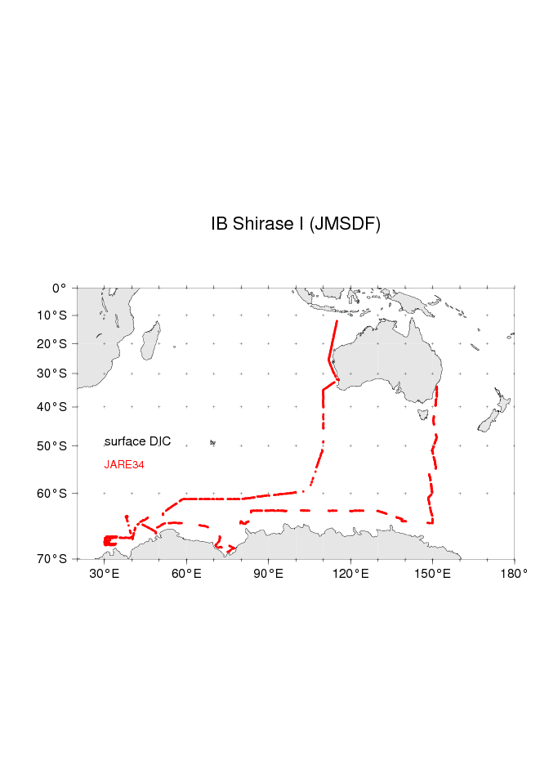
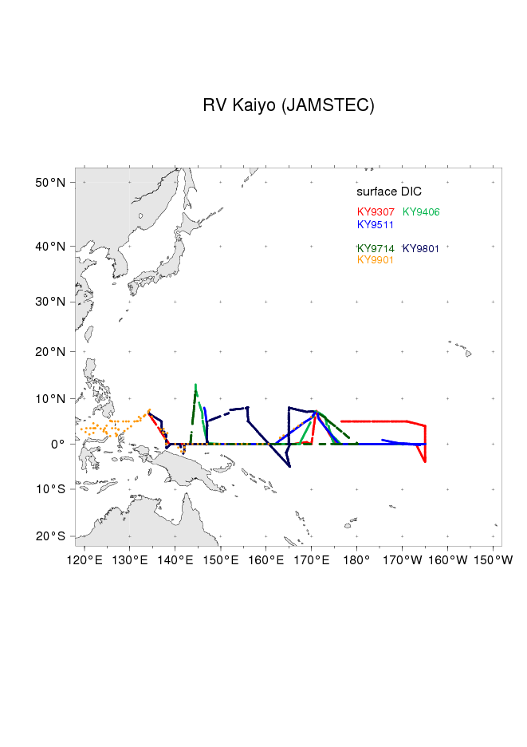
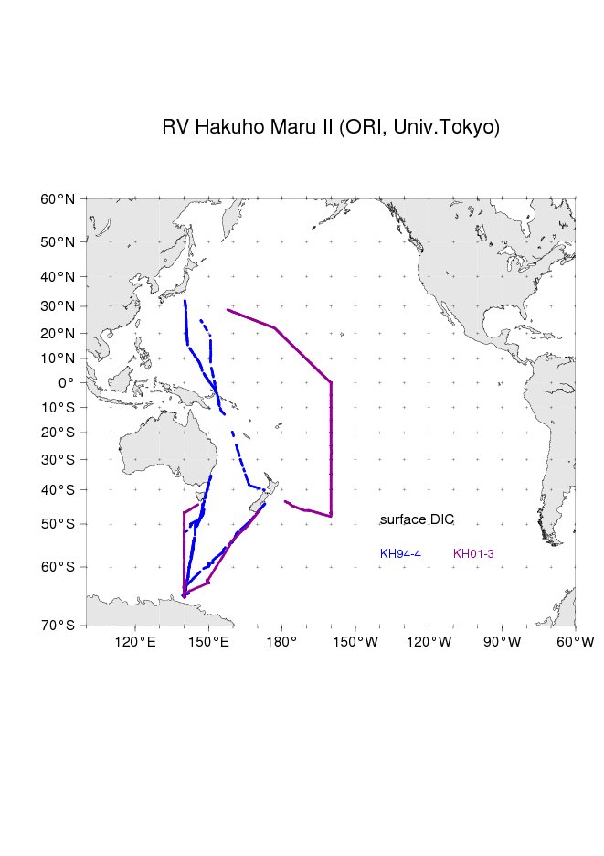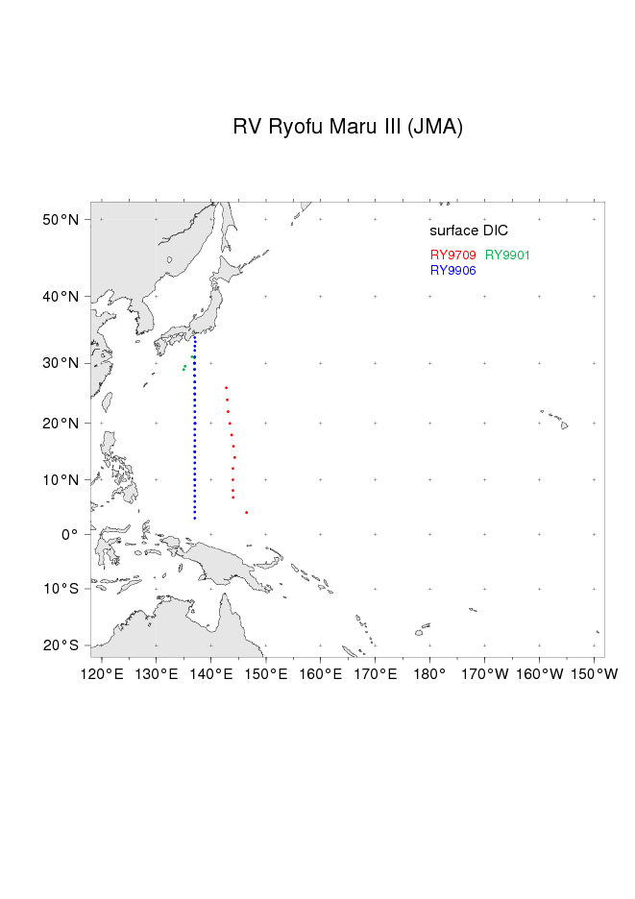
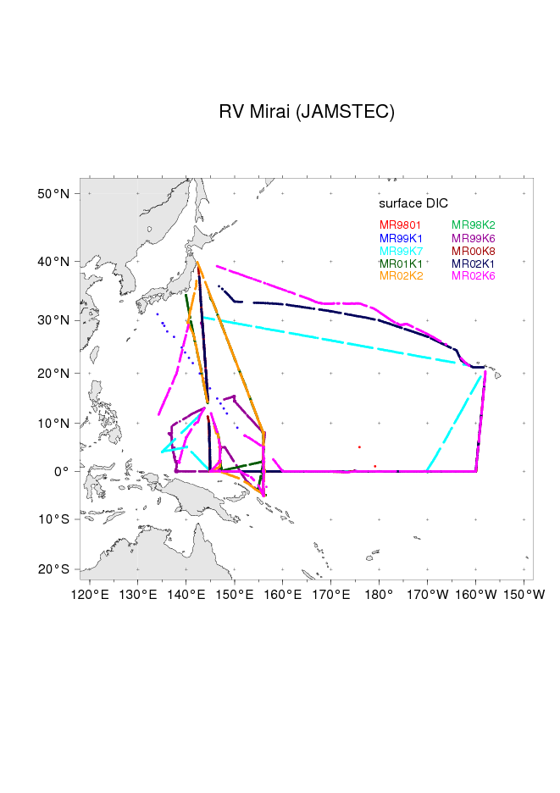

References
- Ishii, M., Inoue, H.Y., Matsueda, H., Tanoue, E., Close coupling between seasonal biological production and dynamics of dissolved inorganic carbon in the Indian Ocean sector and the western Pacific Ocean sector of the Antarctic Ocean. Deep-Sea Research I, 45, 1187–1209. 1998.
- Ishii, M., Inoue, H.Y., Matsueda, Net community production in the marginal ice zone and its importance for the variability of the oceanic pCO₂ in the Southern Ocean to the south of Australia. Deep-Sea Research II, 49, 1691–1706, 2000.
- Ishii, M., Inoue, H. Y., Matsueda, H., Saito, S., Fushimi, K., Nemoto, K., Yano, T., Nagai, H., Midorikawa, T., Seasonal variation in total inorganic carbon and its controlling processes in surface waters of the western North Pacific subtropical gyre. Marine Chemistry, 75, 17-32, 2001.
- Ishii, M., Saito, S., Tokieda, T., Kawano, T., Matsumoto, K., Inoue, H. Y., Variability of Surface Layer CO₂ Parameters in the Western and Central Equatorial Pacific. In: Shiyomi et al. ed. Global Environmental Change in the Ocean and on Land. Terrupub, Tokyo, pp 59-94, 2004.
- Inoue, H.Y., M. Ishii, Variations and trends of CO₂ in the surface seawater in the Southern Ocean south of Australia between 1969 and 2002,Tellus 57B, 58-69, 2005.

