Cruise Report

SCICEX99

USS Hawkbill

Table of Contents
1 Introduction 5
2 Water Column Data Acquisition 7
2.1 Water Samples types 7
2.2 Water Sampling Events 7
2.2.1 Eight Depth Spirals 7
2.2.2 Three Depth Spirals 8
2.3 In-Line Samples 8
2.3.1 Expendable CTD casts 8
2.4 On-board Water Analysis 9
2.4.1 Salinometer 9
2.4.2 Dosimundo2000 10
2.5 Underway Oceanographic Measurements 10
2.5.1 Sail-Mounted CTD data 10
2.5.2 Acoustic Doppler Current Profiler (ADCP) 11
3 Ice Profile Data Acquisition 11
3.1 Upward looking sidescan: 11
3.2 Digital Ice Profiler System-III 11
4 Geophysical Data Acquisition 11
4.1 Instrumentation 11
4.1.1 Submarine Data Recording System (SDRS) 11
4.1.1.1 Navigation Data Quality 12
4.1.2 Seafloor Characterization and Mapping Pods (SCAMP) 13
4.1.2.1 Sidescan Swath Bathymetric Sonar (SSBS) 13
4.1.2.1.1 Sidescan Imagery 13
4.1.2.1.2 Bathymetry 14
4.1.2.2 High Resolution Sub-bottom Profiler (HRSP) 15
4.1.2.3 Data acquisition and Quality Control System (DAQCS) 16
4.1.2.4 Gravimeter 17
5 Operational Phases 18
5.1 Entry and APLIS Ice Camp 19
5.2 Chukchi Borderland Survey 20
5.3 VIP Trip 20
5.4 Alaska Shelf Survey 20
5.5 Cross-Basin Transect 21
5.6 Lomonosov Ridge Survey 21
5.7 North Pole Surfacing 24
5.8 Gakkel Ridge Survey 24
5.9 Yermak Plateau Survey 26
6 Technical Comments and Notes 26
6.1 SCAMP Data Timeouts 26
6.2 SCAMP Alarm 27
6.3 SCAMP Synchronizer 28
6.4 Salinometer Repair 30
7 Conclusions 30

List of Figures
- Overall cruise track for SCICEX-99
- Temperature Transect of the Arctic Ocean from xCTD Data
- Iceberg Scours in SSBS Backscatter
- Northwind Escarpment in SSBS Bathymetry
- HRSP data along the Lomonosov Ridge
- Sample Gravity data
- Chukchi Survey track
- Alaska Shelf Survey track
- Before and After SCICEX Lomonosov Bathymetry
- Lomonosov Ridge Survey track
- Gakkel Ridge Survey track
- Yermak Plateau Survey track
- SSBS data timeout Histogram
- HRSP data timeout histogram
- SCAMP alarm control box
- SCAMP synchronizing circuit block diagram

Introduction
The USS Hawkbill set sail from Pearl Harbor on day 77 (18 March, 1999) for SCICEX 99, the last scheduled cruise of a series of unclassified science cruises to the Arctic Ocean. After transiting the Bering Strait, the ship arrived in the data release area on day 92 (2 April). Equipped for underway geophysical and oceanographic data acquisition and prepared to collect underway water samples, the ship operated throughout the deep Arctic Ocean basin and, by special agreement with the Norwegian government, within a segment of the Norwegian EEZ during the next forty-two days.
Four research programs formed the basis of SCICEX 99 [Figure 1].
- A physical oceanographic survey of the northern Alaskan continental slope (Weingartner, University of Alaska Fairbanks)
- A cross basin physical oceanographic transect in support of acoustic propagation experiments (Mikhailevsky and Moustafa, Science Applications International Corporation)
- A survey of the Chukchi Borderland for iceberg scours (Polyak, Byrd Polar Center, Ohio State University and Edwards, University of Hawaii, Hawaii Mapping Research Group)
- Survey of the Lomonosov and Gakkel Ridges (Coakley, Tulane University; Cochran, Lamont-Doherty Earth Observatory and Edwards, University of Hawaii, Hawaii Mapping Research Group)
A number of other research programs were also serviced by this cruise. These projects, which relied on seawater samples, were put on a not-to-interfere basis by the science steering committee, which oversees the implementation of SCICEX cruises. Samples were collected for these programs throughout the cruise, along the ship tracks defined by the four primary programs. Three types of sample stations were executed during this cruise. Three-depth and eight-depth spiral stations nominally consisted of a spiral ascent of the submarine from a keel depth of 750 feet to a keel depth of 190 feet, during which samples were collected at a series of (three or eight, respectively) pre-defined depths. At In-line stations, samples were collected while the submarine was underway at a constant depth.
SCICEX 99 was focused on underway data acquisition. In addition to the Digital Ice Profiler (DIPS), sail-mounted CTD and Acoustic Doppler Current Profiler (ADCP) instrumentation installed to monitor the water column, the submarine was outfitted with two active sonars to image the seafloor and a Bell BGM-3 gravimeter. The two sonars are a High-Resolution Sub-bottom Profiler (HRSP), which imaged the upper 200 meters of the sediment stratigraphy, and a Sidescan Swath Bathymetric Sonar (SSBS), which imaged the bathymetry and acoustic backscatter of the seafloor over a broad swath. Both of the SCAMP sonars and the BGM-3 gravimeter performed well during each phase of SCICEX. The gravity data and real-time displayed sonar data show a wealth of detail that should substantially improve our understanding of these features.
All the major objectives selected for SCICEX 99 were met. Some additional opportunities were exploited through careful use of time. All of the planned eight and three depth water sample stations were occupied. A number of opportunistic in-line samples were also taken. All budgeted bottles and sample tubes were filled. All planned xCTD launches were executed.
The success of this year’s cruise is, in large part, due to the crew and officers of the USS Hawkbill, who have shown unfailing enthusiasm and support for the science objectives of SCICEX-99. The Commanding Officer, CDR Robert Perry, is due a great deal of credit for fostering this environment.
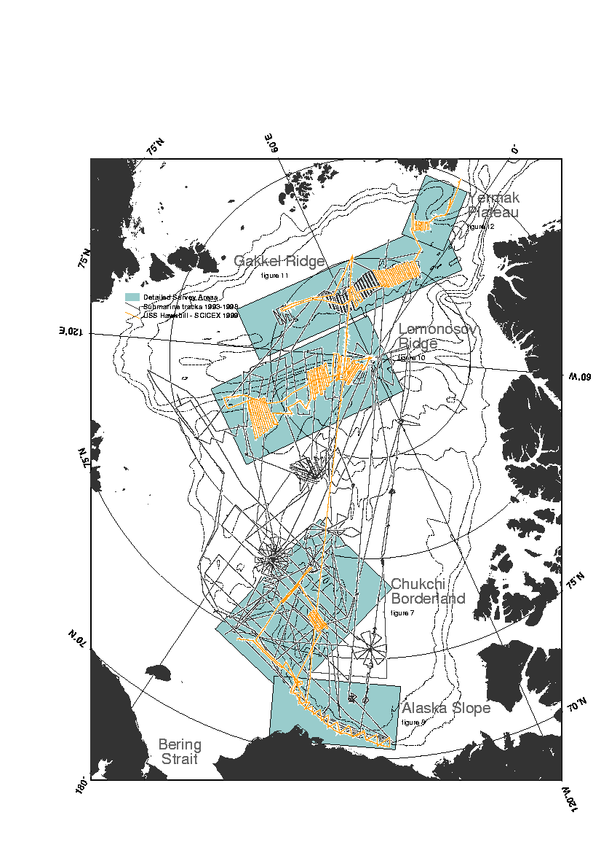
Figure 1 – Tracks for all SCICEX cruises; SCICEX-99 in gold. Survey area boxes are shown in blue with figure number.

Water Column Data Acquisition

Water Samples types
All water samples were drawn via a temporary water line connected to a through-hull fitting and valve assembly (all stainless steel) located outboard of the port torpedo tubes. The through-hull fitting is located eight feet above the keel although the recorded depths for the water samples are given as keel depths.
About five minutes prior to arrival at the designated station locations, valves were opened and the temporary water line was allowed to flush continuously during the sampling process. A thermistor was attached to the downstream end of temporary water line to monitor the temperature of the incoming water.
The suite of water samples drawn included salinity, dissolved oxygen, nutrients, pigments, dissolved organic carbon, dissolved inorganic carbon, particulate organic carbon, iodine-129, cesium-137, tritium, helium, CFC, oxygen-18, and lignin, although not all samples were taken at all sample locations. The individual researchers for whom these samples were acquired are listed at the top of each page of the water sample log.
The following samples were collected in numbered bottles/containers. The individual sampling protocols can be obtained from the respective researchers.
Table 1 – Water samples collected during SCICEX 99.
Sample Type | Volume | Treatment | PI
Nutrient | 125 ml | frozen | Whitledge, UAF
Pigments | 25.8 or 17.2 l | Filtration through GF/F micro-fibre filters, frozen | Whitledge, UAF
DOC | 125 ml | Frozen | Sambrotto, LDEO
DIC/TCO₂/Alk | 250 ml | Add 0.2 ml 50% HgCl₂ solution | Sambrotto, LDEO
Particulate Carbon | 5 l | Filtration through GF/F precombusted micro-fibre filters | Sambrotto, LDEO
Iodine-129 | 1 l | None | Smith, BIO
Cesium-137 | 20 l | None | Smith, BIO
Tritium | 250 ml | None | Schlosser, LDEO
Helium | ~100 ml | None | Schlosser, LDEO
CFC | ~50 ml | Frozen | Smethie, LDEO
Oxygen-18 | 2 oz | None | Schlosser LDEO
Lignin | 20 l | Add 400 mg of HgCl₂ | Benner, UT

The time and depth corresponding to each sample suite were copied from the Digital Ice Profiler System (DIPS) display and recorded in the water sample log.

Water Sampling Events
Three types of water sampling activities were carried out during SCICEX-99: inline, 3-depth spiral hydrocasts, and 8-depth spiral hydrocasts. The diameter of the submarine’s spiral trajectory during the hydrocasts ranged from about 400 m to about 800 m.

Eight Depth Spirals
Water samples were drawn at eight nominal keel depths (750 feet, 640 feet, 540 feet, 440 feet, 380 feet, 330 feet, 260 feet, and 190 feet) although there were a few hydrocasts at which the non-standard depths differed from those listed above. Water samples drawn included the entire suite of samples although not all sample types were taken at each location.

Three Depth Spirals
Water samples were drawn at three standard keel depths (750 feet, 440 feet, and 190 feet) during the submarine’s transit from deep to shallow for daily housekeeping activities. This suite of samples was the same as that for in-line sampling with the addition of iodine 129. There were a couple of instances for which the deepest sampling depth was omitted due to the shallowness of the water.

In-Line Samples
Inline water samples were drawn while the submarine was transiting at a constant depth. The nominal suite of inline samples included salinity, dissolved oxygen, nutrients, pigments, dissolved organic carbon, dissolved inorganic carbon, and particulate organic carbon, although not all of these samples were taken at all inline stations. Individual researchers should check the water sample log for specifics.

Expendable CTD casts
SCICEX-99 took along 153 xCTDs. 150 of these were funded by ONR and purchased by Dr. Muench of Earth and Space Research. To augment these, three 1997-vintage probes were provided out of the Arctic Submarine Laboratory’s inventory. Probes are identified by an 8-digit serial number. The first two numbers in this serial are the year of manufacture, making it easy to identify the older probes.
Because of late initiation of the purchase, Sippican could not deliver the entire order of 150 prior to Hawkbill’s departure from Pearl Harbor. Of the 150 new probes, 24 were delivered prior to the ship’s departure in Hawaii. The remainder of the probes were delivered to the ice camp and loaded on Hawkbill during two of the surfacings.
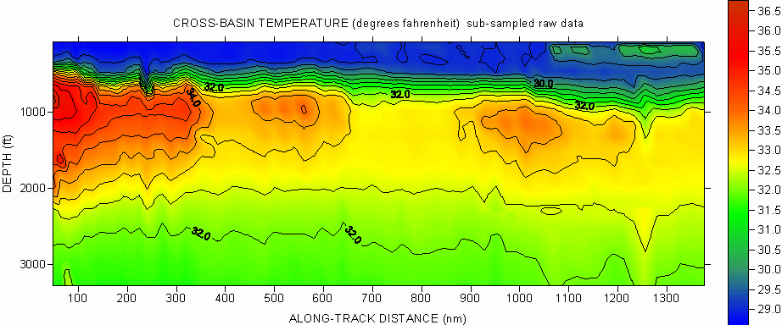All probes were launched from the ship’s after signal ejector using the MK12 Ocean Data Acquisition System, Submarine Platform, V 4.3.1. Once ejected into the seawater, the xCTD rises to approximately 40 feet below the surface. At this depth, a probe containing the temperature and conductivity sensors is released. The probe falls through the water column, communicating with the data logging computer through a fine wire threaded through the signal ejector.
Figure 2 – Cross basin temperature transect collected for Mikhailevsky and Moustafa.
The majority of the probes were launched from a keel depth of 750 feet. Each probe launch that produced any type of data was recorded as a Raw Data File (.rdf) during the actual deployment of the probe. These have been converted to Export Data Files (.edf’s) in both English and Metric units.
Due to limitations in amount of data that can be transmitted through the connecting wire, depth is not directly measured. Sippican has developed an algorithm to compute depth based on time since the start of the drop and an assumed fall rate for the released probe. In recent years, Sippican has started equipping these probes with pressure point squibs to help compare actual depth to computed. All of the probes delivered at the ice camp had these, with trigger depth ranging from the low 900 meter range to just over 1000 meters. One of the probes provided by ASL had an 800m pressure point while the other two had none.
Science Program | xCTDs expended
Alaskan Shelf Survey | 26
Cross-Basin Transect (part 1) | 49
Lomonosov Frontal Survey | 20
Cross Basin Transect (part 2) | 22
Other | 24
Table 2 – Usage of expendable CTDs by project during SCICEX 99.
Probe usage was as detailed above. The probes categorized as “other” were used in conjunction with eight depth spirals, many of which coincided with the probes used for the purposes listed above. The remainder were used for daily housekeeping and backups. All 153 probes were used.
There were 11 failures during this SCICEX-99 for a success rate of 92%, similar to the failure rate from previous SCICEX cruises. The failures mainly consisted of no data being transmitted or high or constant temperature. There were indications of wire stretch on some probes, which were considered to be marginal, but the data recoverable.
The failure rate was less than expected for the deeper (750 feet) launches. The only real concern was the fact that the probe pressure set points were uniformly about 300m deeper than the indicated trigger depths. We do not believe that the computed depth was this greatly in error. There were many probes, particularly along the Alaska Shelf and above the Chukchi Cap/Northwind Rise, which hit bottom before reaching the end of their data run. In all of these cases, the indicated depth at which the probes hit bottom were within a couple feet of actual bottom depth. The cause of the pressure point mismatch will be investigated.
The overall performance of the probes was good. Figure 2 is a profile constructed from sub-sampled raw xCTD data collected along the Mikhailevsky cross-basin transect. While this is a preliminary representation of the temperature field, the continuity of the temperature structures suggests that xCTD performance was consistent during SCICEX 99.

On-board Water Analysis
Some measurements must be made shortly after the sample is taken. For that reason, salinity and DO were analyzed while underway.

Salinometer
Salinity samples were analyzed using a Portasal model 8410 portable salinometer while underway and the respective values recorded in the water sample log.
Each salinity sample was analyzed twice with both resulting salinity measurements recorded in the salinity log. Only the first of these two measurements was entered in the water sample log. If the two salinity measurements differed by more than 0.001 psu, a third salinity measurement was taken and entered in the salinity log. In this case, the median salinity measurement was entered in the water sample log.

Dosimundo2000
Dissolved oxygen samples were analyzed using a Dosimundo 2000 auto-titrator (instrumentation provided by Chris Langdon, Lamont-Doherty Earth Observatory) and the respective values recorded in the water sample log.

Underway Oceanographic Measurements
Continuous, underway monitoring of the water column provided both data on the shallow circulation of the Arctic Ocean and the composition of the seawater.

Sail-Mounted CTD data
SCICEX-99 took along 3 Seabird SBE-19 CTDs. Two were mounted in the sail alongside the camera mount, approximately 49.3 feet above the keel. The CTDs were plumbed to the outside for intake and discharge. Seawater was continuously pumped past the CTD sensors.
Attached to the number one device was a Dissolved Oxygen sensor provided by Lamont-Doherty (Chris Langdon, Lamont-Doherty Earth Observatory) and a Wet Labs WETStar Miniature Fluorometer. Attached to the number two device was a Beckman Dissolved Oxygen sensor and a Wet Labs C Star Transmissometer. They were powered by two separate laptop computers and used the CTD Data Acquisition Software, SEASOFT, Version 4.232. The third SBE-19 was carried as a spare.
Our biggest concern with the ICECATs was the susceptibility of the DO sensors to damage due to freezing while we were on the surface. To avoid this early in the cruise, neither unit had a DO sensor attached when the USS Hawkbill departed Hawaii. Installation took place during the ice camp surfacing just prior to the start of the Alaska Shelf Survey (Day 100; 10 April), the first time that the DO data was really needed.
During the transit north, unit number one developed a drifting depth reading and was replaced with the spare during the initial surfacing. The old unit was returned to CONUS via the ice camp. The new unit initially performed well. Subsequently a regular spike marked the data. The cause of the spike is not known. It appears that the data may be acceptable. Unit number two appeared to perform well throughout the cruise.
The real-time display of data from the number one CTD consistently showed far smoother response than the number two CTD. The behavior was as if a one-minute low pass filter was applied to the data derived from number one. The same behavior was observed during SCICEX 98. Although this behavior was investigated more than once, it has not yet been fully explained.
During each surfacing, both the suction and discharge lines for each device were blown down. A concentrated brine solution was used to douse the internals of each system to prevent freezing. This worked very well. At the North Pole surfacing, the membrane and internal solution was changed on the Lamont-Doherty DO sensor at the request of Chris Langdon.
The data were logged on the hard drives of the ICECAT laptop computers. These were copied onto two 100 MB Zip disks per device. The Zip disks were duplicated for redundancy.

Acoustic Doppler Current Profiler (ADCP)
The upward looking 150 kHz ADCP, was manufactured by RDI Instruments. It was installed on the foredeck of the USS Hawkbill starboard of the centerline. Due to installation requirements, it is tilted slightly forward from horizontal and slightly to starboard from vertical. The ADCP was run continuously during science operations. It appeared to function throughout the cruise. There were no on-board tools for processing of the data so the only indication that data acquisition was occurring was the real-time display and the creation of sequential data files. The primary storage of the data was on the ADCP computer hard drive. Backup files were stored on ZIP disks every few days.

Ice Profile Data Acquisition
Two upward looking sonars imaged the underside of the ice. A Klein System 2000 sonar provided a continuous swath acoustic backscatter image of the ice, which was useful for distinguishing the presence of keels and identifying smooth ice. The DIPS-III/ topsounder sonar measured the projection of the ice into the water directly above the submarine. Both were useful for identifying surfaceable features, but only the DIPS-III data was logged.

Upward looking sidescan:
The dual frequency upward looking Klein 2000 sidescan was mounted on the deck aft of the weapons loading hatch. The role of this sonar was for locating surfaceable features and no scientific data was recorded during this cruise.

Digital Ice Profiler System-III
As with previous SCICEXs, the DIPS was installed to record ice draft. The system used was the DIPS III, unit number one. It has inputs from the ship’s OD-161 Topsounder for ice draft and raw ship’s synchro inputs for ship’s keel depth, heading, and speed. DIPS worked well throughout the deployment.
The data was logged onto the hard drive of the DIPS computer. It was regularly copied onto one 100 MB Zip disk. The Zip disk was duplicated for redundancy.
The overall performance of the system was excellent. The typical keel depth and speed used during most of the cruise (i.e., 750 ft at 16 kts.) reduced the resolution of the ice draft data compared to previous SCICEXs, most likely biasing the ice draft statistics to indicate deeper than actual.

Geophysical Data Acquisition
Geophysical data acquisition during SCICEX 99 built on previous cruises. With the addition of this year’s data set, SCICEX has now accumulated approximately 100,000 km of underway-geophysical data in the deep Arctic Ocean.

Instrumentation

Submarine Data Recording System (SDRS)
The Submarine Data Recording System (SDRS) was installed on board the USS Hawkbill to capture ship’s own data by System Integration Research of Providence, Rhode Island under contract to NUWC. The SDRS captures information from a number of devices on the ship and constructs a binary data stream composed of interleaved synchro, ASCII and binary data. Two hundred and twenty bytes per second of this data are logged by the Data Acquisition and Quality Control System (DAQCS) via an RS-232 connection. In normal operation data is logged to the internal SDRS tape drives.
The logged data consists of ship’s position, orientation and environmental information from the Ship’s Inertial Navigation system (SINS), the GPS receiver (when surfaced), the ship’s own bottom sounder (BQN-17a), ship’s keel depth, roll, pitch, sound speed in water and the ship’s primary time source. Status flags included in the data stream permit monitoring of the SDRS functions and acquisition of the SDRS device time stream.
The latitude, longitude, heading, pitch, roll and ship velocity (total and component) are provided as 14-bit synchro data from the SINS. Ship’s own depth is provided as 14-bit synchro data from the digital depth gauge. Most of the synchro data streams consist of a fine and a course value to provide adequate resolution. Each synchro value is provided once per second. Water depth below the keel and data from the SINS printer are provided as ASCII character data. GPS data is a mixed collection of binary and text data. Multiple one second scans are necessary to construct complete records from each of these three streams.
The SDRS returned the complete data set from most days during the cruise. Beginning on day 105 (15 April) and continuing to day 113 (23 April), a problem with the SDRS interfered with logging of the SDRS data stream by DAQCS. The symptoms were a loss of power error message, a lit battery discharge LED, flashing of the SDRS display and rewinding of the QIC-150 tape which was followed by what appeared to be a seek. These events are the result of the SDRS detecting a power failure and going to standby mode. The SDRS would then restart. During these intervals, the data stream to the DAQCS was disrupted, resulting in numerous gaps in the 1 Hz record.
Gaps in the data were typically about 15 seconds long, but longer gaps of a few minutes were not uncommon. Most days, about 15 minutes of data was lost. On one exceptional day (109; 19 April) the intermittent data gaps summed to nearly two hours of lost data. Removal of the QIC-150 tape, which ended data logging on the SDRS itself, did not remedy the problem, but substantially reduced the time it took for the SDRS to recover from the apparent power loss and the number and extent of data gaps on the DAQCS logged data set.
The problem was eventually traced to overheating which was causing the unit to detect a power failure and go to standby. Additional air was ducted to the SDRS from a nearby vent. This reduced the number of failures. However, we observed that this ventilation source is periodically shut down for maintenance. After adding an independent fan from the SCAMP spares at 2244 UTC on day 113 (23 April), no significant data gaps were observed.
Similar behavior was observed in the SDRS used during SCICEX 98 but it was apparently not fixed.

Navigation Data Quality
The short, intermittent gaps introduced in the ship’s own data logged on the DAQCS by power loss in the SDRS are not expected to be a significant problem. The more important question is the quality of the position information in an absolute sense. During this cruise 'absolute' fixes came from the ship's GPS receiver which only produced data while the boat was surfaced. The SINS was subject to drift during the time between absolute fixes. Due to the ice station visits (days 93, 3 April; 100, 10 April; 101, 11 April; and 106, 16 April), North Pole (day 123, 3 May) and other brief surfacings (days 117, 27 April; and 134, 14 May) the SINS was well constrained by absolute fixes. Fixes were obtained both shortly after entering and shortly before exiting the data acquisition area. Subsequent GPS fixes were distributed such that the longest time between fixes was 11 days. Observed offsets, as described by the Nav ETs and the Navigator, were small, giving confidence that the SINS positional information is of good quality.

Seafloor Characterization and Mapping Pods (SCAMP)
The Seafloor Characterization And Mapping Pods (SCAMP) is a geophysical survey system developed for use on submarines. It consists of a swath mapping sonar known as the Sidescan Swath Bathymetric Sonar (SSBS), and the High Resolution Sub-bottom Profiler (HRSP) swept frequency sub-bottom profiler, a marine gravity meter, and the computer infrastructure to control, monitor, log and validate the data. The data system is referred to at the Data Acquisition and Quality Control System (DAQCS.)

Sidescan Swath Bathymetric Sonar (SSBS)
The SSBS is a Raytheon SeaMARC™ design adapted for use on a submarine operating under an ice canopy. Adaptations include a four-rows/side array design that supports transmit beam steering, packaging to meet the requirements for installation on submarines, and a specially modified telemetry system. The transducer arrays are installed in a pod mounted along the keel of the submarine.
During SCICEX 98 there were problems with the starboard side which were manifested by poor range of sidescan data and very limited bathymetry data. Prior to SCICEX 99 the problems were traced to the failure of two of the five starboard outboard subarray modules caused by saltwater intrusion, and the probably consequent failure of one of the starboard power amplifiers. A remedial effort was undertaken in which the pod was removed and the individual modules tested. Two port modules were also found to have saltwater leakage. Each of these four modules was electrically disconnected and returned to the SSBS pod to maintain weight distribution and fairing. The three remaining modules on each side were re-installed adjacent to one another. This resulted in a significant improvement to the performance of the starboard side, and the prospective reliability of both sides, at the expense of broadening the fore-aft transmit beam pattern and raising the side lobes.
Numerical modeling of the expected performance of the modified array configuration was undertaken as part of the remedial effort. This modeling indicated that the degraded beam patterns would still provide good data quality. Data analysis performed during this cruise indicates that the data quality is very good on both sides and may be improved substantially by enhanced signal processing.
Reduction in the number of active subarray modules changed the effective impedance of the arrays. We were therefore reluctant to run the SSBS at full power during this cruise. Prior to the cruise we sought technical advice from the manufacturer but nothing significant was forthcoming so we chose the prudent path. We did run at full power for some short periods of time. During one of these tests we observed extremely high noise levels in the received data, together with abnormally high current being drawn by the outboard electronics, and telemetry indicating that one of the external power supply voltages was too low. The system was powered down and restarted at the medium transmit power setting, after which it appeared to function normally.
Telemetry between the outboard electronics mounted in the ESM void (under the fore deck) and the inboard electronics in the torpedo room were relatively unreliable during SCICEX 99. Repeated attempts to obtain reasonable technical support from the manufacturer to aid in resolving this problem were unsuccessful between cruises. However, we did add a small alarm system that resulted in a reduction in the amount of data lost to unnoticed telemetry failures and allowed the watch standers to work on evaluating data and improving system performance. This alarm is discussed in Section 6.2

Sidescan Imagery
During this cruise, the sonar was operated over a very wide range of altitudes above the seafloor at ping intervals from 5 seconds to 16 seconds. It produced sidescan swath widths in excess of 166 (±83 degrees) at altitudes of a few hundred meters and swath widths of 16 to 18 km in water depths greater than roughly 1 km.
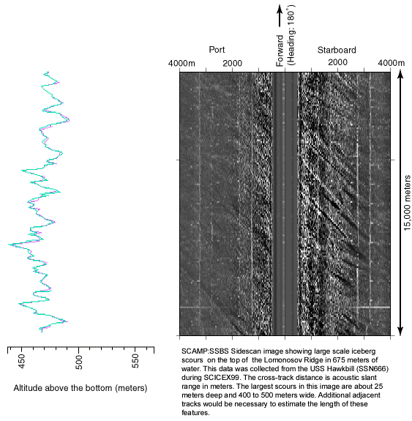Figure 3 – Sidescan swath data with co-registered submarine altitude determined from the first return on the port and starboard sides.
Investigations during the cruise resulted in the development of techniques and software for suppressing beam pattern and acoustic cross talk artifacts in the sidescan data. A synchronizing circuit, described in Section 6.3, was fabricated to reduce or eliminate artifacts caused by acoustic crosstalk from the HRSP sonar. Further enhancement of these methods should result in significantly improved data products.
An example of preliminary processed backscatter data is shown in Figure 3. This data, which shows an intensely scoured region, was collected during day 111 (21 April) southbound along a high adjacent to the western edge of the Lomonosov Ridge.

Bathymetry
Bathymetry in this system is determined from measurement of the phase difference between signals derived from the four rows of elements. In the present implementation, the upper three rows are summed to form a derived “upper” row and the lower three rows are summed to derive the "lower" row. This is currently implemented as a hardware summing circuit in the outboard electronics. The synthesized rows’ signals appear electrically to be roughly 0.9 acoustic wavelength apart, leading to ambiguities in the relationship between acoustic arrival angle and phase difference angle.
The existing method of extracting the phase differences between the rows worked very well on the port side data but exhibited problems with the starboard side. Detailed investigation of this problem during the cruise suggested several possible sources of error. Averaging the SSBS data along track reveals an unexpected notch in the starboard beam pattern at a depression angle of about 25 degrees below bore sight. There is phase-coherent noise, possibly a result of both center physical rows being used to synthesize the derived rows. In addition, there is a statistically significant difference in the amplitudes of the upper and lower rows on the starboard side, which is not present on the port side. These issues were investigated at length during the cruise and a strategy for implementing more robust phase difference processing was developed. Further effort in this direction will be required to fully develop, implement and test improved processing methods, and to eliminate the cause of these problems for future survey work.
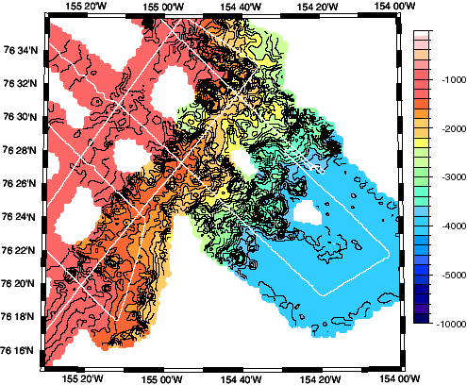
Figure 4 – Processed SSBS bathymetry across the Northwind Escarpment. White lines indicate tracks of the USS Hawkbill along which swath data was collected to make this gridded data set.
Figure 4 shows the bathymetry data collected during survey of the Northwind Escarpment. The high relief on the edge of this rise and complex bathymetry is well imaged in the swath bathymetry data.

High Resolution Sub-bottom Profiler (HRSP)
The SCAMP HRSP is a modified version of a Bathy-2000P developed in close collaboration with Ocean Data Equipment Corporation. The HRSP transmits a frequency-modulated chirp from an array of nine elements mounted in a pod on the ship's keel. During this cruise a 50 millisecond linear sweep from 2.75 to 6.75 kHz was most commonly used. Except in a few cases the system was used at full power (2 kilowatts) at all times. Sonar and status data were logged by DAQCS.
A number of improvements were made to the HRSP firmware based on the performance of the system during SCICEX 98. These included improved bottom tracking, the (limited) ability to accept an external trigger pulse, improved handling of external inputs including time and date, and corrected display of several parameters on the real-time screen. Unfortunately, there was not enough time between cruises to implement some of the other desired improvements such as automatic file size limiting and keel-depth corrected real-time display and stable external synchronization.
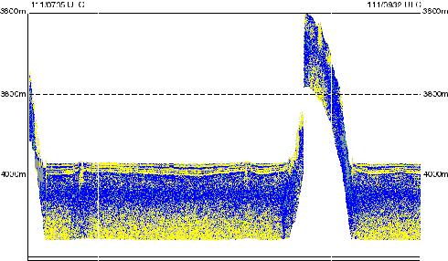
One of the significant issues with the performance SCAMP last year was the acoustic cross talk in the SSBS data from the HRSP. During transmit, the HRSP sweeps through three frequencies having harmonics at the SSBS receive frequency of 12 kHz. These frequencies are 3 kHz, 4 kHz and 6 kHz. Analysis of the SSBS data undertaken during this cruise clearly documented that the crosstalk signature from the HRSP which appears in the SSBS data consists of small consistent peaks at the time that the HRSP sweep passes through each of these frequencies.
Figure 5 – Sub-bottom profiler data collected in the Barents Basin in transit from the Gakkel Ridge to the Yermak Plateau. Well laminated sediments, with some evidence of diapiric disruption, characterize the abyssal plain. Signal intensity increases from yellow through blue. The figure covers 33 nautical miles (61 km) of track. The vertical exaggeration is approximately 77:1.
During the course of the cruise a synchronizing circuit was developed and tested that allowed the HRSP to operate synchronously with the SSBS. The Synchronizer is discussed in section 6.3. Unfortunately, the current firmware release in the HRSP is not particularly robust when operating in external synchronization and as a result the HRSP crashed significantly more often during synchronized operation that it does when operating independently.
An example of the HRSP data is shown in Figure 5, which was collected at the edge of the Lomonosov Ridge. The stratigraphy of the adjacent abyssal plain, at about 3810 meters depth is well imaged by this high resolution instrument.

Data acquisition and Quality Control System (DAQCS)
The DAQCS provides the computer infrastructure to support the data acquisition, logging and validation necessary for successful data collection at sea. The version implemented for SCAMP is evolved from a sequence of systems that originated on the R/V Conrad in 1985 running on single processor 68010 based Masscomp computers running a real-time Unix variant called RTU. Over time the core system has been expanded and adapted to run on Sparc-based single and multi-processors under a succession of Sun Operating systems from Sun-OS 3.1 through Solaris 5.3, under X86-based Linux systems, and on several generations of MIPS-based single and multi-processors from Silicon Graphics.
In the SCAMP implementation there are two Sun Ultra2 servers rack mounted in Artecon Sphinx enclosures, which also contain additional peripherals. One server acts as the real-time system while the other is used for offline data archiving and quality control. All interaction with DAQCS is provided through laptop computers. Three NEC 6050MX laptops running the RedHat 5.2 Linux distribution provide the principle displays by way of X11 servers. One laptop is connected to the first serial interface of each Ultra2 (/dev/ttya) to provide single user and boot time control through a terminal emulator running on the laptop.
The real-time system interfaces with the SSBS through an Sbus interface card that implements a high speed digital interface known as a TI 'C40 comport. Software provided by Raytheon provides the real-time displays necessary to operate the SSBS and to capture its data to disk. Additional software collects the SSBS data from disk, applies a narrow band decimation filter and translates the SSBS data from “atk” format provide by the Raytheon code into “tts” format that is used in subsequent data processing. The tts-format files are decimated by a factor of five as part of the narrow band filtering.
The interface between DAQCS and the HRSP has several data channels. Time, position and depth data are provided to the HRSP from DAQCS via a serial interface. Two status message streams (one for routine messages and another for errors) are transferred from the HRSP to DAQCS via serial interfaces. The HRSP sonar data is written across a 10BT network connection to one of the DAQCS disks using the Network File System protocol.
Digital data from the SDRS (section 4.1.1), the second sail mounted CTD (section 2.5.1) and from the Gravimeter (section 4.1.2.4) comes to DAQCS for real-time display on unidirectional asynchronous serial interfaces.
The SSBS data is internally time-tagged with DAQCS CPU time by the Raytheon supplied software. The HRSP is time-synchronized with DAQCS via serial interface and applies this time stamp to the data files it creates. The SDRS data stream has two times imbedded in it: one from the ship's precision frequency reference and a second that is simply the CPU time of the SDRS computer. All other data streams have DAQCS CPU time prepended to the data message.

Gravimeter
A Bell BGM-3 shipboard gravimeter loaned for this cruise from NAVOCEANO at Stennis Space Center, Mississippi, was installed for this cruise. The raw gravity data was interfaced to DAQCS via a Lamont Gravity Meter buffer that generated one second data records.
The Bell BGM-3 underway marine gravimeter is designed to operate with minimal attention. During SCICEX 99 it did just that. Data Not Valid (DNV) conditions were rare. The few observed platform DNVs were brief transients, less than 20 seconds, that appear to have been associated with the water sampling spirals. No sensor DNVs were observed during the course of the cruise. Both platform and sensor voltages were regularly checked and observed to be within specifications. At no time was the sensor observed to draw on the battery back-up power.
While underway, the PRC and sensor heaters cycled regularly. The BPTC heater was not observed to cycle, but given the long duty cycle typical of this heater, that is not unusual. As specified in the Sensor subsystem manual, the fuse for the BPTC was checked. It was continuous. Given that both of the other heaters were cycling, indicating that the sensor was at temperature, no further action was taken.
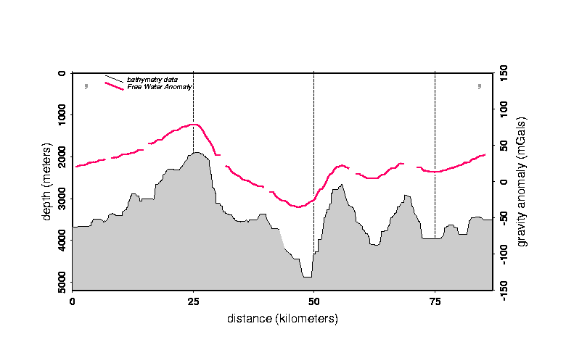Prior to the cruise, after installation on the USS Hawkbill, the BGM-3 was off power for some days. The loss of power resulted in a loss of heat to the sensor. When heat is lost for any significant period to time, the calibration of the instrument can be disrupted. Once the blunder was recognized, the sensor was plugged in and allowed to re-equilibrate. Gravity ties done on day 19 (19 January; 855302.9) and a few days after plugging it back in, on day 52 (21 February; 855286.2), bracket the power loss, giving some indication of the disturbance to the sensor. A subsequent tie done at the time of the science shakedown cruise, (day 75; 16 March⁾ yielded a bias of 855298.5, 4.4 milliGals less than the pre-power loss value. This was interpreted as indicating that the sensor had largely recovered from the thermal shock of power loss. A closing gravity tie will be done in Portsmouth, England at the end of the cruise. A second closing tie may be done prior to removing the meter in Port Everglades, Florida.
Figure 6 – Gravity and bathymetry profile from the Gakkel Ridge, showing characteristic blocky bathymetry and high amplitude gravity anomalies. Data collected day 130 between 19:40 and 22:40 UTC.
Data from the gravimeter was reduced daily. The reduced data, when well correlated with the ship’s own depth gauge data, is smooth and continuous. It is well correlated with the observed bathymetry [Figure 6], indicating that the meter has performed well during SCICEX 99.

Operational Phases
SCICEX 99 was broken up into a series of phases, defined by the region where the USS Hawkbill operated and the activity that defined the ship’s track during that time. Each segment of the cruise is described here.

Entry and APLIS Ice Camp
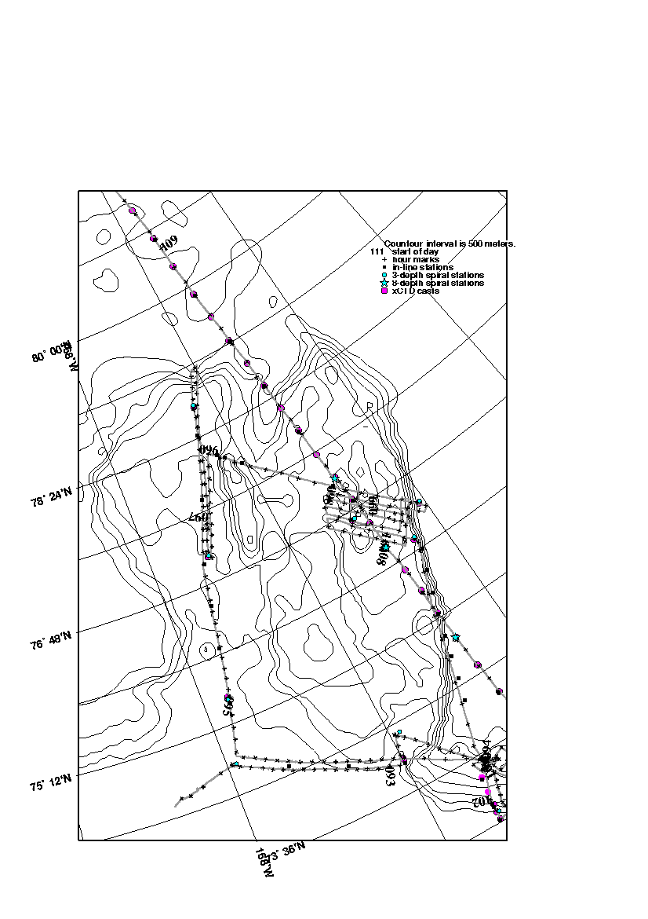Ice Camp APLIS (for Applied Physics Laboratory Ice Station) was established in the western Beaufort Sea to support personnel transfers during SCICEX-99. Hawkbill surfaced four times at APLIS (days 93; 3 April, 100; 10 April, 101; 11 April and 106; 16 April). In addition to personnel transfers, Hawkbill loaded food, spare parts, and the bulk of the xCTDs during these surfacings.
Figure 7 – Chukchi Borderland survey track, notations indicate various water sampling events and time along the track of the USS Hawkbill. Bathymetry constructed from narrow-beam data collected this year, previous SCICEX bathymetry data and archival data.
The surfacings also presented the opportunity to change the science party to reflect the science activities during the different phases of the cruise. Dale Chayes (Lamont-Doherty Earth Observatory), Mark Rognstad (University of Hawaii Manoa) and Steve Okkonen (University of Alaska Fairbanks) boarded the USS Hawkbill in Pearl Harbor and rode it north through the Bering Strait, making preparations for the science operations while underway. Chief scientist Margo Edwards (University of Hawaii Manoa) joined the ship during its first surfacing (day 93) to participate in both the Alaskan Slope survey and the Chukchi Borderland survey. Terry Whitledge and Dean Stockwell (University of Alaska Fairbanks) joined the ship during the third surfacing (day 101), after the VIP cruise, to support the Alaskan Slope survey. At the final surfacing (day 106) Margo Edwards and Terry Whitledge left to return home and Bernard Coakley (Tulane University) joined the ship, in support of the Gakkel and Lomonosov Ridge surveys, replacing Margo Edwards as chief scientist.
Media. Four different media events were conducted during this operation.
During the northbound transit to the Arctic, two Navy media personnel were embarked to photograph and document that phase of the operation.
From day 103-110 (3-10 April), USS Hawkbill embarked two personnel from Cable News Network (CNN) and two from National Geographic Magazine.
From day 111-116 (11-16 April), USS Hawkbill embarked two personnel from a private production company preparing a documentary on SCICEX and one reporter from the Christian Science Monitor.
During the APLIS surfacing on day 116, USS Hawkbill embarked, briefed, and toured eight reporters from various news and media agencies.

Chukchi Borderland Survey
The Chukchi Borderland survey was planned to image iceberg scours on the Chukchi Cap and collect some data over a nearby slope, which forms the eastern edge of this plateau. While underway, Margo Edwards, chief Scientist and co-PI on the proposal to do this work, re-oriented the survey [Figure 7] after a few lines over the Chukchi Cap, to map the Northwind Escarpment in some detail [Figure 4]. The bathymetric data resulting from this series of crossings reveals the dramatic relief of the Northwind Escarpment (Figure 4).

VIP Trip
Twelve VIPs were embarked overnight from day 110-111 (10-11 April). The purpose of this embarkation was to allow senior government personnel an opportunity to observe submarine Arctic operations first-hand and be briefed on SCICEX. VIPs embarked were:
Sen. Charles Robb D-VA
Dr. John Hamre Deputy Secretary of Defense
Mrs. Julie Hamre Dr. Hamre’s wife
Hon. Richard Danzig Secretary of the Navy
Dr. Herbert L. Buchanan III Deputy Secretary of the Navy for RD&A
ADM Jay Johnson Chief of Naval Operations
ADM Skip Bowman Head of Naval Nuclear Power
Ms. Phoebe Novakovic Spec. Asst. to Secretary & Deputy Secretary of Defense
Dr. Rita Colwell Director, National Science Foundation
Mr. Bill Natter Prof. Staff Member, House Armed Services Committee
RADM Al Konetzni Commander Submarine Force, US Pacific Fleet
RADM Grog Johnson Military Asst. to Dr. Hamre
Table 3 – Participants in the VIP cruise to and from APLIS conducted during SCICEX 99.

Alaska Shelf Survey
The goal of the Alaska Near-Shelf Survey was to investigate the circulation and thermohaline structure of Chukchi-Beaufort continental slope waters [Figure 8]. Specific objectives for this survey were to measure the decorrelation length scale of the along-slope density field, the magnitude and structure of the along-shore pressure gradient, and along-slope variations in the cross-slope baroclinic pressure gradient. These measurements are directly related to the scales of cross-slope exchanges and forcing mechanisms for the eastward-flowing undercurrent.
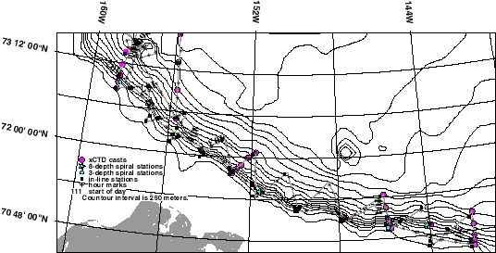
Figure 8 – Alaska shelf survey track, annotated with various water sampling events. Bathymetry was constructed from narrow-beam bathymetry data from this cruise, previous SCICEX cruises and archival data.
Primary sampling was performed using the sail-mounted CTDs and submarine-launched expendable CTDs. In plan view, the submarine track described a 21-leg saw-toothed pattern above the continental slope [Figure 8], each leg of which was approximately 30 nm in length. Water samples were taken at a depth of 190 feet inshore of the 500 fathom isobath and at a depth of 440 feet seaward of the 500 fathom isobath.

Cross-Basin Transect
As in all previous SCICEXs, a long Cross-Basin Transect was conducted to collect hydrographic and ice profile data [Figure 1]. For this year, the track closely approximated the SCICEX-98 track, offset approximately 5nm closer to the North Pole. The transect was conducted in two parts, separated by the Lomonosov Ridge Survey and the North Pole surfacing [Figure 2]. The first was from day 107 (17 April) at about 0300 UTC to day 111 (21 April) at about 0200 UTC. The second was from day 124 (4 May) at about 0630 UTC to day 125 (5 May) at about 1615 UTC. A total of 71 xCTDs were scheduled for the total evolution. Including backups, a total of 76 probes were used and nine 8-depth submerged hydrocasts conducted. Unlike previous years, the probes were not launched at regular intervals. Instead, spacing varied between 16 nm to 24 nm with the closer spacing being used in those areas where previous data indicated more rapid change.

Lomonosov Ridge Survey
The Lomonosov Ridge is a long sliver of continental crust, perhaps analogous to Baja California, that was rifted off the Barents Shelf by the propagation of the Gakkel Ridge across the Arctic. Data collected during SCICEX show a sinuous, continuous ridge that spans the basin, dividing the Eurasia from the Amerasia Basin. This contrasts with its map representation in the GEBCO chart, which shows a narrow, straight ridge with a substantial gap near the North Pole [Figure 9]. The combined gravity and bathymetry data have been used to identify the location of a series of half-grabens that segment the ridge into a series of high-standing en echelon blocks.
While the Lomonosov Ridge is flanked on the Eurasian basin side by an active spreading center, no fossil or active plate boundaries have been recognized in the Amerasian basin. There must be a plate boundary somewhere on the Amerasian flank of the Lomonosov Ridge. Identification and mapping of this boundary would be a substantial advance in understanding the plate tectonic history of the Amerasian Basin.
During SCICEX 99 SCAMP data was acquired across three distinctive sections [Figure 10] of the Lomonosov Ridge to document its origins and relationships with adjacent extended continental and oceanic crust in both the Eurasian and Amerasian basins.
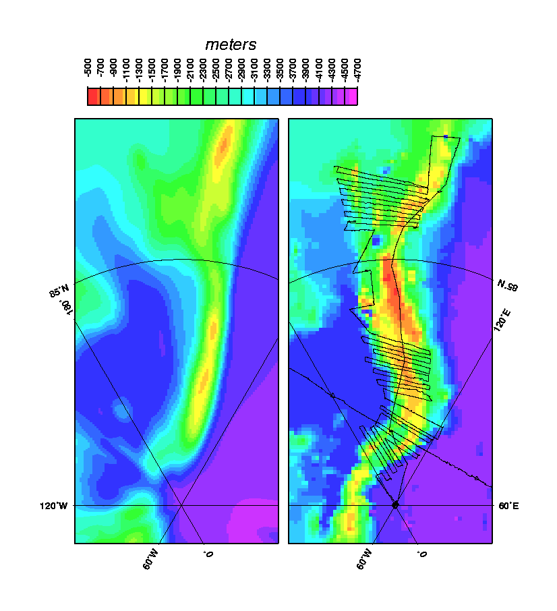
After leaving ice station APLIS Hawkbill sailed south and east towards the Alaskan coast to pick up the Mikhailevsky cross-basin profile. Hawkbill followed the cross-basin transect until encountering the Lomonosov Ridge. At this point the submarine broke off to survey the ridge. Running south, along the western ridge flank to begin the first part of the planned survey, the ship continued four hours further south than was planned. Extension of this line was at the request of PIs Polyak and Edwards to expand the search for iceberg scours to lower latitudes.
Figure 9 – Comparison between DBDB 5 bathymetry at the Lomonosov Ridge and the ridge as revealed by SCICEX and archival bathymetry. SCICEX 99 track of the USS Hawkbill is shown as a fine black line. The ridge is sinuous, segmented by a series of bathymetric lows. As mapped, there is no central gap in the ridge, which is also located farther east than in the earlier data set.
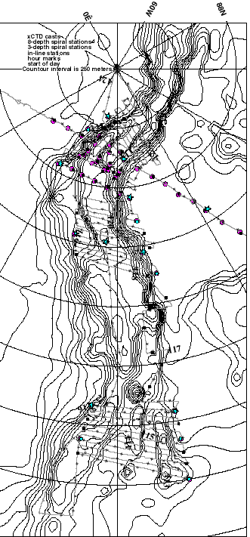
The southernmost segment was surveyed as planned. The subsequent transit to the central survey area was repositioned, and a number of transects across the ridge extended, to better define the edges of the ridge and make the most of available time. During the northbound transit towards the central survey the ship stayed on the eastern side of the ridge, repeatedly crossing the eastern edge [Figure 10]. The central survey was run as planned, but the lines on the Amerasian side were run out to the abyssal plain (about 3810 meters depth) to ensure that the full extent of the high-standing Lomonosov Ridge was imaged with SCAMP. Each of the planned lines in each survey box was run to at least the full planned extent.
Figure 10 – Lomonosov Ridge tracks from SCICEX 99, annotated with the water sampling events conducted during this phase of the survey. Bathymetry is derived from SCICEX narrow beam and archival data.
To cover as much of the ridge as planned, it was necessary to adjust the northern survey. The survey was changed to eliminate redundancy with the Mikhailevsky profiles from this year and last. This resulted in substantial time savings and allowed the Hawkbill to map most of the area indicated in the science test plan. Most lines in this survey were continued to the abyssal plain on each side of the ridge (~4200 meters depth on the Eurasian side, ~3800 meters depth on the Amerasian side [Figure 5]), again to ensure complete characterization of the ridge.
After some hours at the pole the Hawkbill dove and re-joined the Mikhailevsky profile, filling in one gap in the Lomonosov survey [Figure 1]. After completing the Mikhailevsky line, Hawkbill relocated to the axis of the Gakkel ridge.

North Pole Surfacing
The ship surfaced at the North Pole on day 123 (3 May) to have crew liberty and perform burial services. The surfacing proceeded with no problems through approximately 10 inches of ice. There was good ice to port. The liberty and memorial services were held as planned. The ship submerged at about 2200 UTC the same day.
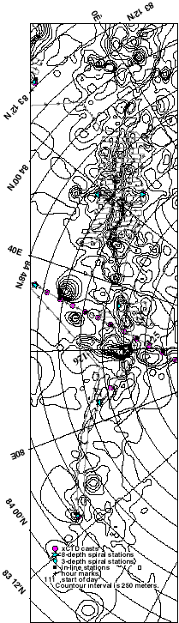
Figure 11 – Tracks of the Gakkel Ridge survey. Annotations indicate hours, start of day and water sampling events. Bathymetric grid was constructed from SCICEX narrow-beam data as well as archival data.

Gakkel Ridge Survey
Although the development of the Eurasia basin is well understood in the context of global plate tectonics, very little is known about the morphology, structure, petrology or distribution of sediments on the Gakkel Ridge. There is no information on the existence or distribution of magmatic activity, hydrothermal vents or benthic vent communities.
Approximately 3300 track km of data were collected along axis of the Gakkel Ridge during SCICEX 1998 using SCAMP [Figure 1]. The ridge was mapped in out to 50 km either side of the axis for about 500 km, to give complete swath coverage along two segments of the ridge.
During SCICEX 1999 cruise, the USS Hawkbill sailed east along the axis of the Gakkel Ridge [Figure 10] to image the youngest seafloor formed at full spreading rates of approximately 1 cm/year. The USS Hawkbill was able to complete most of the planned axial survey of the eastern extension of the Gakkel Ridge. A total of six hours were cut from this segment of the cruise to preserve adequate time to complete subsequent phases of the cruise.
After running east along the ridge axis, the submarine filled in the gap between the two 1998 survey blocks. Continuing west, the Hawkbill completed mapping of the faster spreading portion of the Gakkel Ridge in the operational area.
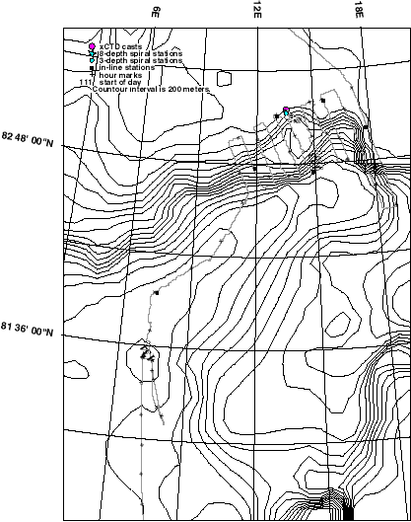
As a result of SCAMP mapping performed during SCICEX 98 and 99, the axial zone of the Gakkel Ridge has been imaged across a region formed at full spreading rates ranging between 1.0 and 1.3 cm/year. The faster spreading portions (1.15-1.3 cm/year) of the ridge have been mapped out to 50 km on either side of the axis.
Figure 12 – Location of Yermak Plateau survey lines. USS Hawkbill passed out of the extended data acquisition area when it cross 80 N.

Yermak Plateau Survey
This year, for the first time, as the result of an invitation from the Norwegian government, SCICEX operated in a non-US EEZ. The Navy accepted the invitation and permitted data acquisition in the region extending north from 80 N to the edge of the data acquisition area defined for SCICEX, bounded by 6 E and 20 E.
Data was acquired across a sediment drift deposit north and east of the Yermak Plateau [Figure 12] at the recommendation of Dr. Yngve Kristoffersen. The southbound transit was run over the axis of the plateau, across a number of highs that have been selected for possible drilling in 2001.

Technical Comments and Notes
During the cruise a number of technical problems emerged with various pieces of hardware. This section documents these problems and the fixes that were developed while underway.

SCAMP Data Timeouts
For various reasons, both sonars shut down unexpectedly more often than is typical of systems of this complexity. During SCICEX 98, the first SCAMP cruise, the watchstanders were required to stare at the SCAMP screens nearly full time to catch telemetry failures and restart the system expediently. The SCAMP Alarm (discussed in section 6.2) was implemented to improve this situation.
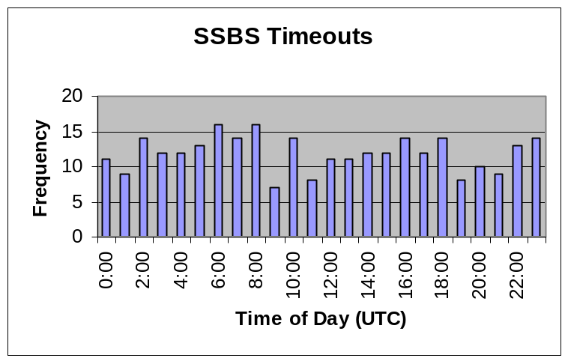A digital telemetry system links the inboard and outboard SSBS electronics. A lack of error detection and recovery in the telemetry system causes statistically random unrecoverable transmission errors. Errors in the outbound direction result in loss of the ability to transmit instructions to the outboard electronics. Errors in the inbound direction result in the loss of sonar data.
Figure 13 – SSBS timeouts plotted against time of day UTC.
Outbound errors are annoying in that desired changes can only be implemented by power cycling the outboard electronics. Due to the wide dynamic range of the receivers it is not necessary to change operating parameters often. A side effect of outbound telemetry failure is that the external blanking function can not be reliably transmitted to the outboard electronics.
Inbound telemetry errors are a very serious fault as they result in lost data. These failures occurred a total of 286 times during the 42 days of operation in the data release area. Recovering from a failure required shutting down the acquisition and control software, cycling the external electronics power, and restarting the software, a process typically taking 1 – 2 minutes. The few times the alarm was not re-enabled resulted in longer outages, but the average gap was still just 3.5 minutes. A total of 16 hours 40 minutes was lost or 1.6% of the total time; this is roughly half the percentage loss of last year. Analysis of the periodicity of the timeouts from both cruises indicates that they are statistically random [Figure 13]. Several attempts have been made to determine the source of the errors, but we have not yet solved the problem. It seems likely that without either substantial support from the vendor, access to the source code for the various 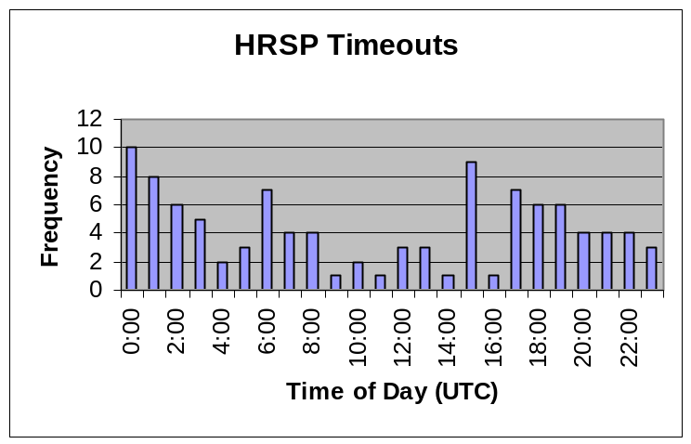processors in the system, or replacement of the telemetry system it is unlikely that we will be able to resolve the problem satisfactorily.
Figure 14 – HRSP timeouts plotted against time of the day (UTC).
The HRSP proved more reliable, especially during the early part of the cruise when running unsynchronized with the SSBS; a total of 104 failures took place [Figure 14]. Communications timeouts between the processors making up the HRSP system could at times be reset by stopping and restarting data logging; in these cases, the data gap was short, and its duration not logged. This method would not work when running with external sync, for unknown reasons. When the quick method was unsuccessful, restarting the HRSP required powering down its acquisition electronics, rebooting the system, logging back in to the DAQCS data logger, resetting operational parameters, and reacquiring bottom tracking. The average time logged for these restarts was 9 minutes, and a total of thirteen hours was lost due to these failures.

SCAMP Alarm
The SCAMP data alarm [Figure 15] is designed to detect the failure of either of the SCAMP sonars and alert the operator to restart the failed system. It does this by monitoring the Tzero pulses produced by the HRSP and SSBS when they begin to transmit, and sounding an alarm and illuminating red Light Emitting Diodes (LEDs) if no Tzero pulse occurs for more than approximately 20 seconds. The alarm is made up of three parts: a ISA bus circuit board, located in the SSBS PC enclosure, a remote control box, with status LED’s, control switches, and the alarm sound generator, and remote visual indicator(s) that can be connected via BNC cables to provide additional visual alarm indicators.
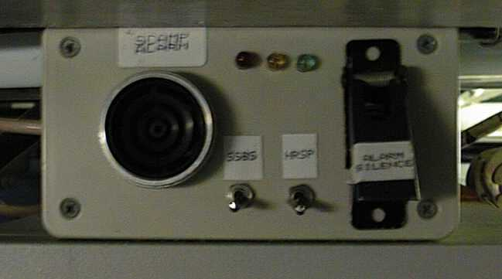
The control box contains LED’s that indicate the status of the monitoring system. Green indicates that the audible alarm is enabled, and that the monitored sonars have transmitted within the last 20 seconds. Yellow indicates that the audible alarm is disabled, but that the sonars are still operating. The red LED lights when one or both monitored sonars fail to transmit for more than 20 seconds; if the audible alarm switch is up, the audible alarm will also sound. Switches on the control box allow the alarm to be disabled for one or the other sonar while remaining active for the other, to allow for alarm operation when one sonar is shut down. Additional remote status indicators can be attached; these indicators are simply bicolor LED’s which light up green when the sonars are operating and red when they fail.
Figure 15 - SCAMP alarm box. Note switches that silence either the SSBS or the HRSP alarm or both.
While the alarm circuit has proven extremely useful in minimizing data loss when one or the other sonar system malfunctions, the fact that the audible alarm can be switched off has led to occasional extended data outages. These take place when the watchstander switches off the audible alarm, usually in response to a failure, but then forgets to re-enable it after restarting the failed system. An improvement to the alarm circuit would be to drive the audible alarm from a set-reset flip-flop, set by the Tzero timeout as at present, but reset by a momentary switch.
We also observed a few occasions when the established timeout period was not quite long enough. The adjustment of the timeout period for each channel is set by a variable resistor on the circuit board inside the rack mounted PC chassis. Due to the tight packaging requirements of this system, access to the adjustments is difficult and can not be done without shutting the entire system down. In the future, better access to such adjustments can be made by bringing them out to the front of the chassis. This type of access is readily available in a number of back-plane configurations such as VME, CompactPCI.

SCAMP Synchronizer
The SCAMP synchronizing circuit is designed to synchronize the two sonars that make up SCAMP, the subbottom profiler (HRSP) and the swath mapping sonar (SSBS), in order to minimize acoustic interference. At present, it has two modes of operation, a single ping mode and a multi-ping mode. In single ping mode, every time the SSBS transmits, a command will be sent to the HRSP to transmit, unless the HRSP is busy processing a previous ping. In multi-ping mode, the repetition period of the SSBS and the ping processing time of the HRSP are measured by the synchronizing circuit. The HRSP is given a ping command when the SSBS transmits, and after it has completed acquisition of that ping, will be commanded to ping again if enough time remains before the next SSBS transmit. As many HRSP pings as will fit into the SSBS period will be inserted. Time measurements are made in integral seconds, and HRSP ping commands are always issued an integral number of seconds with respect to SSBS 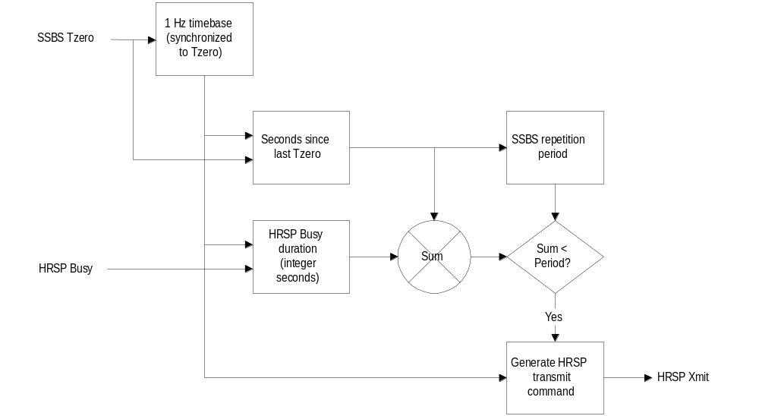pings.
Figure 16 – Circuit schematic for sonar synchronizer board.
A block diagram of the prototype is shown in Figure 16. It consists of a Lattice Semiconductor Programmable Logic Device, a Fox programmable crystal oscillator, and line drivers/receivers. The two reconfigurable components (a programmable oscillator and a logic device) are programmed from an IBM compatible computer printer port, using software provided by their respective manufacturers.
In operation, it was observed that the response of the HRSP to a ping command was delayed by an amount ranging from 200 to 1020 milliseconds in intervals of 160 msec. The delay amount would jump from one value to the next longer value when a “CESP Resync” message appeared on the HRSP display. This message would appear whenever a transmitter or receiver setting was altered, and every 40 minutes after the last “CESP Resync” message. Six test circuits were programmed to produce transmit commands earlier than the SSBS Tzero by the amounts of delay observed, to see if the two sonars could be more closely synchronized by advancing the ping command. However, advancing the HRSP ping command had no effect on the HRSP timing, until the command was advanced by more than second before the actual ping time, in which case the ping advanced by a second.
The present circuit, developed while survey operations were in progress, could not be integrated into the system enclosure without disruption of data acquisition. Once the system is no longer in continuous use, the synchronizer circuit could be assembled on the ISA board that presently houses the data loss alarm. This board is installed in the SSBS PC chassis, where the SSBS Tzero signal is available; a cable from the back of the board would connect to the HRSP. The HRSP ping done signal is only valid when the HRSP is set for external sync; if that could be modified to be active at all times, it could replace the HRSP Tzero signal now used by the alarm, eliminating a cable needed by the current configuration. An external switch can be installed on the enclosure to select single ping or multi-ping modes (in the prototype configuration, the mode has been changed by loading the appropriate programming code.)

Salinometer Repair
The pump on the Salinometer failed during the cruise. The broken part was not included in the spare parts kit loaded on the USS Hawkbill. Fastening the broken plastic parts together with a screw repaired the salinometer.

Conclusions
SCICEX 99 must be accounted as a fully successful science cruise. All major objectives were achieved. All major instrumentation functioned well. The minor problems that did come up were resolved in a timely way.
Effective collaboration with the officers and crew of the USS Hawkbill are much of the reason this cruise worked well. More than any previous SCICEX cruise, the men of the USS Hawkbill responded in real time to science opportunities, adjusting the planned cruise track to meet the opportunities recognized by the science staff. This flexibility was deeply appreciated and helped make the cruise as successful as it was.
While the success of the second Hawkbill cruise is an exceptional achievement, there were a number of disappointments that underline the need for improved instrumentation if SCICEX continues beyond this, the final scheduled cruise.
The thermal problems with the SDRS during the cruise highlight a continuing vulnerability of SCICEX underway data acquisition. The SDRS has always been the weak link in data acquisition. SCICEX is extremely vulnerable to failure of the SDRS. Were the SDRS to fail, the primary link to the ship’s data would be lost. While some of this data could be recovered from deck logs, it would be completely inadequate to support geophysical data reduction.
While access to US Navy submarines for unclassified science cruises has provided an exceptional data set for a number of Arctic scientists, the potential of submarine access to the Arctic is only just being realized. It is to be hoped that SCICEX will continue in some form for as many years as is practicable.

